
Year 9 Mathematics
Mini-Test - Statistics
Resource Section (Calculators and notes allowed)

Time: 30 mins Name: _________________________________ /30 marks

Questions 1 to 5 are Multiple Choice

1. Which type of data best represents hand spans (the length of your hand) of a class? (1 mark)

a) Categorical Data b) Discrete Numerical Data c) Continuous Numerical Data d) Survey

2. Which word best describes a survey question that leads people to answer in a certain way? (1 mark)

a) Biased b) Outlier c) Census d) Random Sampling

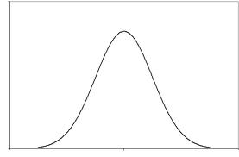
3. What is the best way to describe the following graph? (1 mark)

a) Positively Skewed b) Negatively Skewed c) Symmetrical d) Bi-modal

4. Which measure of location would be best used when finding a normal house price in a street that has 10 houses priced at approximately $500 000 and one priced at $2 million? (1 mark)

a. Mean b. Median c. Mode d. Range

5. Which type of graph would be best to display the results of a census on people’s salaries? (1 mark)

a. Dot Plot b. Stem & Leaf Plot c. Column Graph d. Histogram
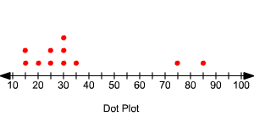

Questions 6 and 7 are not multiple choice

6. Consider the following dot plot. (5 marks)

- What is the mode of the data?

- What word is used to describe the value of 85?

- Which measure of location (mean, mode, median) is most affected by this value?

- Calculate the range with and without this value. Which range is more appropriate for this data and why?
Show all your working.

7. The scores of the Fremantle Dockers and the West Coast Eagles games for 2017 (so far) are as follows:

Fremantle: 75 56 89 106 67 62 116 72 86 43 85 64 72 80 86 44 48 86

West Coast: 136 116 65 91 75 103 97 69 64 90 77 83 96 87 88 74 85 113

- Present this information as a back-to-back stem and leaf plot. (4 marks)

- Calculate the mean, mode, median and range for each team. Show working where needed. (8 marks)

 | Fremantle | West Coast
Mean

Mode

Median

Range

- Based on the data, which team do you think has had a better season so far? Explain with evidence.
(3 marks)

- Draw a histogram for just Fremantle’s scores (4 marks)

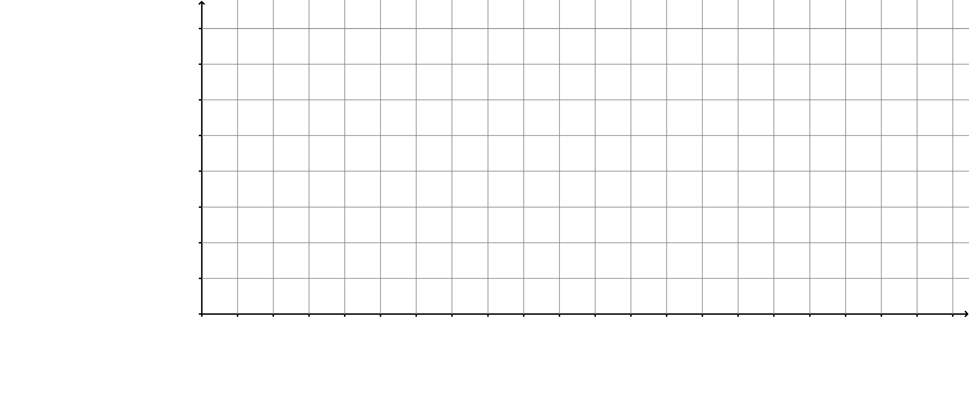

- Describe the shape of the distribution. (hint: don’t forget to use words like ‘skewed’) (1 mark)

